*********************
TELLERING functions
*********************

-----------------
CASH REQUISITIONS
-----------------

1. Check current user position
If SPUSER.spuserpos # '1'
Display message 'This module is for Tellers only'
EXIT
Endif

2. FILTER CASHREQ.DBF FOR reqname = current user

3. DISPLAY GRID showing fields reqamt, reqdate, reqtime

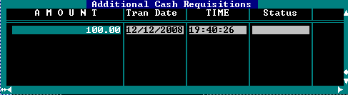

4. Show options ‘ADD’, ‘DELETE’, ‘EXIT‘

5. If ‘ADD’

GET input field for reqamt

INSERT INTO CASHREQ reqamt, reqname, reqdate, reqtime VALUES
entered value, current user, sysdate, current time

6. If ‘DELETE’
Delete current record

7. DELETE FROM CASHREQ WHERE where reqamt = 0

8. EXIT module

-----------------
CASH TRANSFERS
-----------------

1. Check current user position
If SPUSER.spuserpos # '1'
Display message 'This module is for Tellers only'
EXIT
Endif

2. FILTER CASHTRA.DBF FOR traname = current user

3. DISPLAY GRID showing fields tranameto, traamt, tradate, tratime

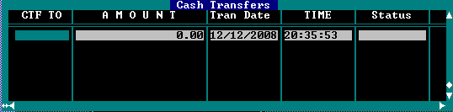

4. Show options ‘ADD’, ‘DELETE’, ‘EXIT‘

If ‘ADD’

GET field tranameto, traamt
Validate tranameto:
If blank Display ‘ERROR: Blank field’
If not in SPUSER.DBF, Display ‘ERROR: User not Found’
If record in SPUSER.DBF = current user,
Display ‘ERROR: Cannot transfer to self’
If SPUSER.spuserpos # ‘1’
Display ‘ERROR: Can only transfer to teller’

IF Valid
INSERT INTO CASHTRA traamt, tranameto, traname, tradate, tratime
VALUES input traamt, input tranameto, current user, sysdate,
current time

If ‘DELETE’
Delete current record

7. DELETE FROM CASHTRA WHERE (traamt = 0 or empty(tranameto))

8. EXIT module

-----------------
END OF DAY
-----------------

1. Check current user position
If SPUSER.spuserpos # '1'
Display message 'This module is for Tellers only'
EXIT
Endif

2. Compute for items to display

SUM ALL trancre FROM SDTRAN FOR (reversed=false AND user=current user
AND trandate = sysdate AND trancode = ‘NCD,’CSD’) to xcashsav

SUM ALL trancre FROM SDTRAN FOR (reversed=false AND user=current user
AND trandate = sysdate AND trancode = ‘LCD,’NLD’,’OUS’) to xcrsav

SUM ALL trandeb FROM SDTRAN FOR (reversed=false AND user=current user
AND trandate = sysdate AND trancode = ‘WD,’NWD’) to xwith

SUM ALL othamount FROM SDOTHERS FOR (othuser=current user
AND othdate = sysdate AND othtype = ‘A’) to xaddltd

SUM ALL othamount FROM SDOTHERS FOR (othuser=current user
AND othdate = sysdate AND othtype = ‘B’) to xcrcr

SUM ALL othamount FROM SDOTHERS FOR (othuser=current user
AND othdate = sysdate AND othtype = ‘C’) to xcracc, xchkenc

SUM ALL othamount FROM SDOTHERS FOR (othuser=current user
AND othdate = sysdate AND othtype = ‘D’) to xref

SUM ALL othamount FROM SDOTHERS FOR (othuser=current user
AND othdate = sysdate AND othtype = ‘E’) to xemer

UPDATE SPTELLER SET addltd=xaddltd, crcr=xcrcr, cracc=xcracc, chkenc=xchkenc,
ref=xref, with=xwith, emer=xemer, ctfname1=spaces, ctfname2=spaces,
ctfname3=spaces, ctfamt1=0, ctfamt2=0,ctfamt3=0,cttname1=spaces,
cttname2=spaces, cttname3=spaces cttamt1=0,cttamt2=0,cttamt3=0,
cashsav=xcashsav,crsav=xcrsav WHERE tname=current user

SUM ALL reqamt FROM CASHREQ WHERE reqname=current user TO accreq

UPDATE SPTELLER SET addmreq=addlreq+accreq WHERE tname=current user

UPDATE SPTELLER SET addcash=cashb+cocib+addmreq+cashsav+cashor+addltd+
ctfamt1+ctfamt2+ctfamt3, addchecks=crsav+croro+
cracc+crcr, addtotal=addcash+addchecks,
cttcend=tccount, chkdep=cocib+crsav+croro+cracc+crcr-coci,
totdisp=dib+ref+with+chkenc+cttamt1+cttamt2+
cttamt3+coci+m.chkdep+emer,
balend=addtotal+totdisp,
over=cttcend-cbalend,
WHERE tname=current user

For each record in SPTELLER, update all cash transfers made to/from
- SCAN CASHTRA for tranameto = SPTELLER.tname
SUM traamt for each unique traname
a. UPDATE field CTFNAME1 to CTFNAME3 for each unique traname
b. UPDATE field CTFAMT1 to CTFAMT3 for the sum of each traname

- SCAN CASHTRA for traname = SPTELLER.tname
SUM traamt for each unique tranameto
a. UPDATE field CTTNAME1 to CTTNAME3 for each unique tranameto
b. UPDATE field CTTAMT1 to CTTAMT3 for the sum of each tranameto

3. DISPLAY SCREEN from SPTELLER record of current user
(open input field for data entry if EDIT mode)

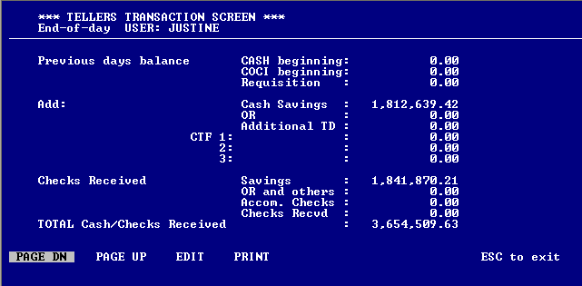

WHERE:

Previous days balance CASH beginning = cashb
COCI beginning = cocib
Requisition = addmreq
Add: Cash Savings = cashsav
OR = cashor
Additional TD = addltd
CTF 1 = ctfname1 + ctfamt1
2 = ctfname2 + ctfamt2
3 = ctfname3 + ctfamt3
Checks Received Savings = crsav
OR and others = croro
Accom. Checks = cracc
Checks Recvd = crcr
TOTAL Cash/Checks Received = addtotal

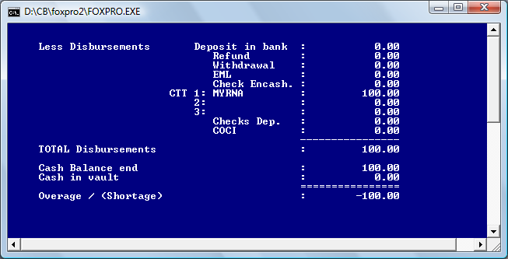

Less Disbursements Deposit in bank = dib
Refund = ref
Withdrawal = with
Add: EML = emer
Checks Encash. = chkenc
CTT 1 = cttname1 + cttamt1
2 = cttname2 + cttamt2
3 = cttname3 + cttamt3
Checks Dep. = chkdep
COCI = coci
-------------
TOTAL Disbursements = totdisb

Cash Balance end = cbalend
Cash in vault = cttcend
=============
Overage / (Shortage) = over

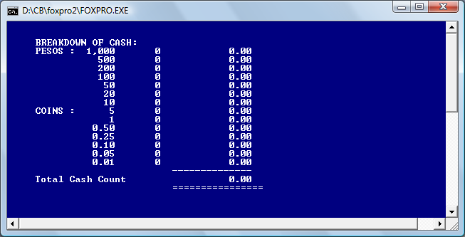

PESOS : 1,000 = (b_1000) + (b_1000 * 1000)
500 = (b_500) + (b_500 * 500)
200 = (b_200) + (b_200 * 200)
100 = (b_100) + (b_100 * 100)
50 = (b_50) + (b_50 * 50)
10 = (b_10) + (b_10 * 10)
COINS : 5 = (b_5) + (b_5 * 5)
1 = (b_1) + (b_1 * 1)
0.50 = (b_p50) + (b_p50 * .5)
0.25 = (b_p25) + (b_p25 * .25)
0.10 = (b_p10) + (b_p10 * .1)
0.05 = (b_p05) + (b_p05 * .05)
0.10 = (b_p01) + (b_p01 * .01)

Total Cash Count = tccount

tccount = b_1000*1000 + b_500*500 + b_200*200 + b_100*100 +;
b_50*50 + b_20*20 + b_10*10 + b_5*5 +;
b_1*1 + b_p50*.5 + b_p25*.25 +;
b_p10*.1 + b_p05*.05 + b_p01*.01

UPDATE SPTELLER tccount=tccount, cttcend=tccount

